 **Table of Contents:-**

1. **INTRODUCTION** 
   1. Project Overview
   2. Purpose
2. **LITERATURE SURVEY**
   1. Existing problem
   2. References
   3. Problem Statement Definition
3. **IDEATION & PROPOSED SOLUTION**
   1. Empathy Map Canvas
   2. Ideation &Brainstorming
   3. Proposed Solution
   4. Problem Solution fit
4. **REQUIREMENT ANALYSIS**
   1. Functional requirement
   2. Non-Functional requirements
5. **PROJECT DESIGN**
   1. Data Flow Diagrams
   2. Solution & Technical Architecture
   3. User Stories
6. **PROJECT PLANNING & SCHEDULING**
   1. Sprint Planning & Estimation
   2. Sprint Delivery Schedule
   3. Reports from JIRA
7. **CODING & SOLUTIONING (Explain the features added in the project along with code)**
   1. Feature 1
   2. Feature 2
   3. Database Schema (if Applicable)
8. **TESTING** 
   1. Test Cases
   2. User Acceptance Testing
9. **RESULTS**
   1. Performance Metrics
10. **ADVANTAGES & DISADVANTAGES**
11. **CONCLUSION**
12. **FUTURE SCOPE**
13. **APPENDIX**

###### **Source Code**

###### **GitHub & Project Demo Link**

## 1. INTRODUCTION :-

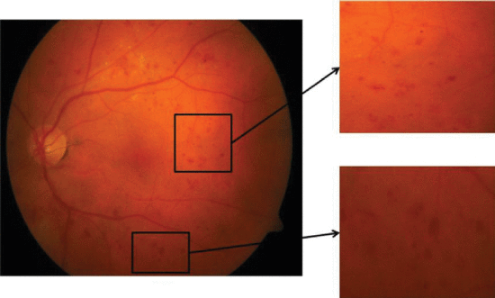The main causing of visual loss in the world is diabetic retinopathy. In the initial stages of this disease, the retinal microvasculature is affected by several abnormalities in the eye fundus such as the microaneurysms and/or dot hemorrhages, vascular hyper permeability signs, exudates, and capillary closures . Micro-aneurysm dynamics primarily increase the risk that the laser photo coagulation requires progression to the level . Diabetic retinopathy lesions are commonly accepted to be reversed and the progression of the retinopathy can only be slower during the early stages of the disease. The identification by repeated examination of patients affected of these initial lesions (mainly Micro aneurysms and small blood cells) is expected as a new possibility of improving retinopathy treatment. Floating and flashes, blurred vision, and loss of sudden vision can be common symptoms of diabetic retinopathy .

# 1.1 Project Overview :-

Diabetic Retinopathy (DR) is a common complication of diabetes mellitus, which causes lesions on the retina that affect vision. If it is not detected early, it can lead to blindness. Unfortunately, DR is not a reversible process, and treatment only sustains vision. DR early detection and treatment can significantly reduce the risk of vision loss. The manual diagnosis process of DR retina fundus images by ophthalmologists is time, effort and cost-consuming and prone to misdiagnosis unlike computer-aided diagnosis systems.

Transfer learning has become one of the most common techniques that has achieved better performance in many areas, especially in medical image analysis and classification. We used Transfer Learning techniques like Inception V3,Resnet50,Xception V3 that are more widely used as a transfer learning method in medical image analysis and they are highly effective.

**1.2 Purpose :-**

The Proposed work intends to automate the detection and classification of diabetic retinopathy from retinal fundus image which is very important in ophthalmology. Most of the existing methods use handcrafted features and those are fed to the classifier for detection and classification purpose. Recently convolutional neural network (CNN) is used for this classification problem but the architecture of CNN is manually designed. In this work, a genetic algorithm based technique is proposed to automatically determine the parameters of CNN and then the network is used for classification of diabetic retinopathy. The proposed CNN model consists of a series of convolution and pooling layer used for feature extraction. Finally support vector machine (SVM) is used for classification. Hyper-parameters like number of convolution and pooling layer, number of kernel and kernel size of convolution layer are determined by using the genetic algorithm. The proposed methodology is tested on publicly available Messidor dataset. The proposed method has achieved accuracy of 0.9867 and AUC of 0.9933. Experimental result shows that proposed auto-tuned CNN performs significantly better than the existing methods. Use of CNN takes away the burden of designing the image features and on the other hand genetic algorithm based methodology automates the design of CNN hyper-parameters.

# 2. LITERATURE SURVEY :-

**ABSTRACT**

**EXISITING PROBLEM:-**

Diabetic Retinopathy (DR) is a degenerative disease that impacts the eyes and is a consequence of Diabetes mellitus, where high blood glucose levels induce lesions on the eye retina. Diabetic Retinopathy is regarded as the leading cause of blindness for diabetic patients, especially the working-age population in developing nations. Treatment involves sustaining the patient’s current grade of vision since the disease is irreversible. Early detection of Diabetic Retinopathy is crucial in order to sustain the patient’s vision effectively. The main issue involved with DR detection is that the manual diagnosis process is very time, money, and effort consuming and involves an ophthalmologist’s examination of eye retinal fundus images. The latter also proves to be more difficult, particularly in the early stages of the disease when disease features are less prominent in the images. Machine learning-based medical image analysis has proven competency in assessing retinal fundus images, and the utilization of deep learning algorithms has aided the early diagnosis of Diabetic Retinopathy (DR). This paper reviews and analyzes state-of-the-art deep learning methods in supervised, self-supervised, and Vision Transformer setups, proposing retinal fundus image classification and detection. For instance, referable, nonreferable, and proliferative classifications of Diabetic Retinopathy are reviewed and summarized. Moreover, the paper discusses the available retinal fundus datasets for Diabetic Retinopathy that are used for tasks such as detection, classification, and segmentation. The paper also assesses research gaps in the area of DR detection/classification and addresses various challenges that need further study and investigation.

**REFERENCES:-**

**Survey 1 :**

**AUTHORS:** Mohammad Z. Atwany ,Abdulwahab H. Sahyoun , And Mohammad Yaqub (March 22).

**TITLE:** ‘Deep Learning Techniques for Diabetic Retinopathy Classification: A Survey.’ **METHODS:** This paper reviews and analyzes state-of- theart deep learning methods in supervised, self-supervised, and Vision Transformer setups, proposing retinal fundus image classification and detection. For instance, referable, nonreferable, and proliferative classifications of Diabetic Retinopathy are reviewed and summarized. Moreover, the paper discusses the available retinal fundus datasets for Diabetic Retinopathy that are used for tasks such as detection, classification, and segmentation

**Survey 2 :**

**AUTHORS:** Mohamad HazimJohari ,Hasliza Abu Hassan , Ahmad Ihsan Mohd Yassin (July 2018).

**TITLE:** ‘Early Detection of Diabetic Retinopathy by Using Deep Learning Neural Network.’ **METHODS:** This project presents a method to detect diabetic retinopathy on the fundus images by using deep learning neural network. Convolution Neural Network (CNN) has been used in the project to ease the process of neural learning. The data set used were retrieved from MESSIDOR database and it contains 1200 pieces of fundus images. The images were filtered based on the project needed. There were 580 pieces of images types has been used after filtered and those pictures were divided into 2, which is Exudates images and Normal images. On the training and testing session, the 580 mixed of exudates and normal fundus images were divided into 2 sets which is training set and testing set. The result of the training and testing set were merged into a confusion matrix. The result for this project shows that the accuracy of the CNN for training and testing set was 99.3% and 88.3% respectively.

**Survey 3 :**

**AUTHOR:** Recep Emre Hacisoftaoglu (Dec 2019).

**TITLE:** ‘Deep Learning Frameworks For Diabetic Retinopathy Detection Using Smartphone-Based Retinal Imaging Systems.’

**METHODS:** In this thesis, we first investigate the smartphone-based portable ophthalmoscope systems available on the market and compare their Field of View and image quality to determine if they are suitable for Diabetic Retinopathy detection during a general health screening. Then, we propose automatic Diabetic Retinopathy detection algorithms for smartphone-based retinal images using deep learning frameworks, AlexNet and GoogLeNet. To test our proposed methods, we generate smartphone-based synthetic retina images by simulating the different Field of View with masking the original image around the optic disk and cropping it.

**Survey 4 :**

**AUTHORS:** Lei Lu , Ying Jiang , Ravindran Jaganathan , and Yanli Hao. (Jan 2019). **TITLE:** ‘Current Advances in Pharmacotherapy and Technology for Diabetic Retinopathy: A Systematic Review.’

**METHODS:** Direct injections or intra virtual antiinflammatory and anti angiogenesis agents are widely used pharmacotherapy to effectively treat DR and diabetic macular edema (DME). However, their effectiveness is short term, and the delivery system is often associated with adverse effects, such as cataract and increased intraocular pressure. Further, systemic agents and plants-based drugs have also provided promising treatment in the progression of DR. Recently, advancements in pluripotent stem cells technology enable restoration of retinal functionalities after transplantation of these cells into animals with retinal degeneration. This review paper summarizes the developments in the current and potential pharmacotherapy and therapeutic technology of DR. Literature search was done on online databases, PubMed, Google Scholar, clinitrials.gov, and browsing through individual ophthalmology journals and leading pharmaceutical company websites.

**2.3.PROBLEM STATEMENT DEFINITION:-**

Diabetic Retinopathy (DR) is common complication of diabetes mellitus, which will cause lesions on the retina that affects vision. If it is not detected early, it can lead to blindness. Unfortunately, DR is not a reversible proves, and the given treatment will only give us a sustain vision. DR early detection and treatment can significantly reduce the risk of vision loss.

**WHAT ?** In contrast to computer-aided diagnosis systems, the manual / human-based diagnosis process of DR retina fundus images by doctors (ophthalmologists) is time-consuming, labor-intensive, expensive, and prone to error.

**WHY ?**Diabetes-related retinopathy is brought on by high blood sugar levels harming the eye's iris. which could result in a permanent loss of vision.

**WHEN ?** Early on, the DR has no symptoms, but later on, the vessels may start to leak a tiny amount of blood into your retina..

**WHERE ?**Blurred vision, Distorted vision will occur.

**WHO?**  It is common among the Diabetic patients.

**HOW ?** The manual early detection of this DR is a challenging task.

**OBJECTIVES** :

The primary goal is to identify diabetic retinopathy by processing retinal images. Transfer learning has arose as one of the most popular techniques that has enhanced performance in many areas, notably in the analysis and classification of medical images. We used transfer learning techniques that are more frequently used in medical image analysis and have been extremely effective, including such Inception V3, Resnet50, and Xception V3.

# 3.IDEATION PHASE & PROPOSED SOLUTION :

# 3.1 Empathy Map Canvas :

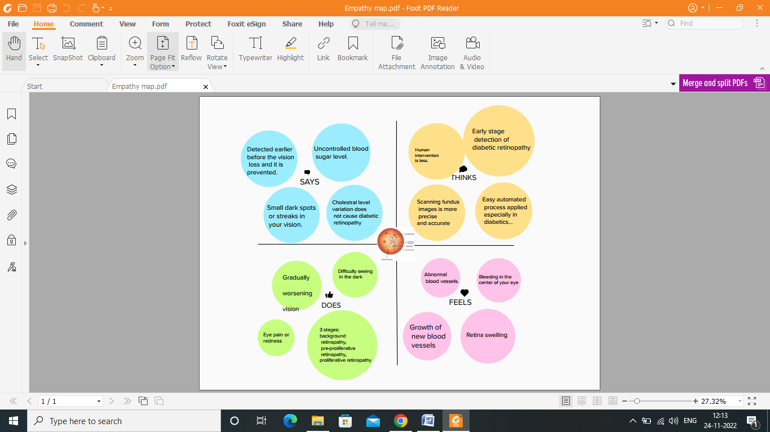

**3.2 IDEATION AND BRAINSTORMING:-**

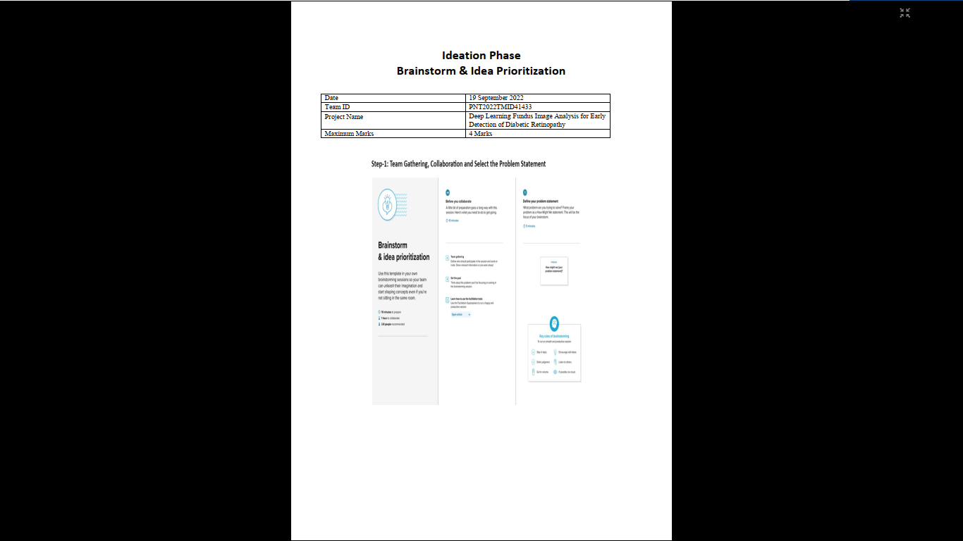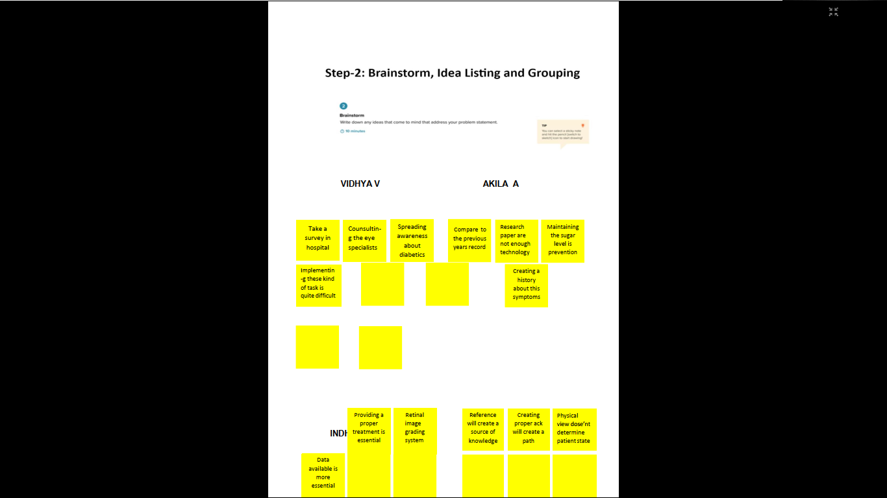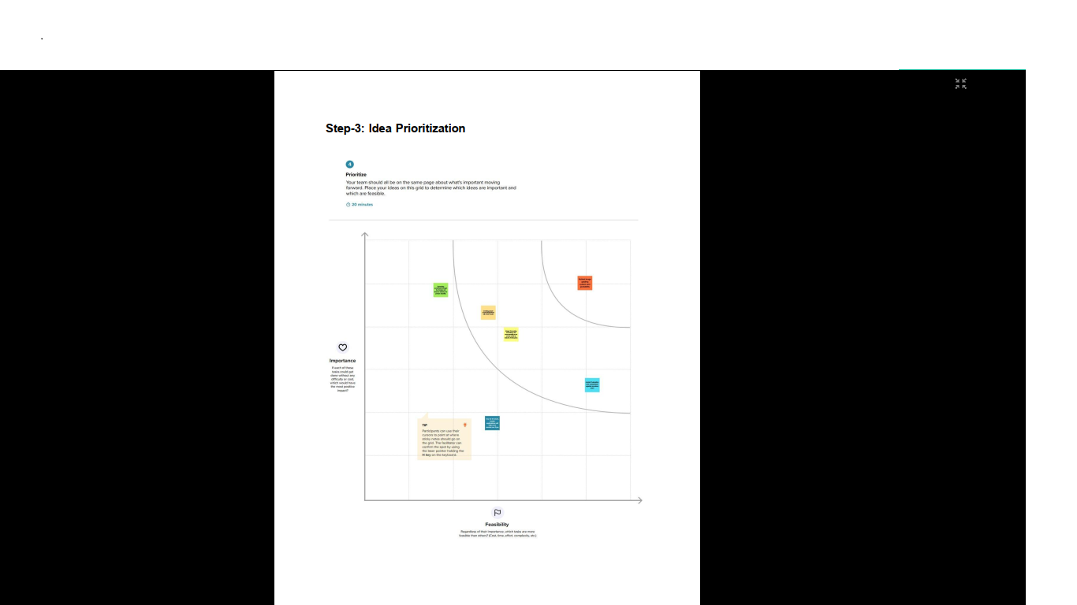

**3.3 PROPOSED SOLUTION:-**

|  |  |  |
| --- | --- | --- |
| **S.No.** | **Parameter** | **Description** |
| 1. | ProblemStatement (Problemtobesolved) | Analyzing a fundus image can help identifydiabeticretinal diseaseearly.   * AnalyzethelevelofDR * TodetectwhetherDRispresentornot |
| 2. | Idea/Solutiondescription | 1. The goal is to identify diabetic retinopathyfrom the fundus image dataset as soon aspossible,allowingindividualstoproceedwiththenecessarytreatmentsandavoidtemporaryor permanentvisionloss. 2. We will create a deep learning model (CNN)with high accuracy to detect DR and protectpeople at risk of losing their vision becausethereisnocompletecureforthisformof   DR. |
| 3. | Novelty/Uniqueness | On the basis of the level of DR performed duringanalysis, a class-based classifier will be provided.As part of the work, we'll also test out a transferlearningstrategythathasthepotentialtobevery  successfulandleadtoimprovedperformance. |

|  |  |  |
| --- | --- | --- |
| 4. | SocialImpact/CustomerSatisfaction | Peoplewholosetheirvisioncouldactuallybenefitfromthisandlive.Earlyanalysisanddetection of DR is crucial for minimizing socialimpact because it can help patients keep theirvision. |
| 5. | BusinessModel(RevenueModel) | * Doctors can analyze and identify DR usingthismodel,whichfunctionsasaservicemodel for public hospitals and a businessmodelfor private hospitals. * Evenexportingittoothernationswhorequireitcanworkas a businessstrategy. |
| 6. | ScalabilityoftheSolution | Thereareincreasinglymoreapproachestoscalethe solution so that the model is simple tocombinewithemergingtechnologies. |

**3.4 PROPOSED SOLUTION FIT**

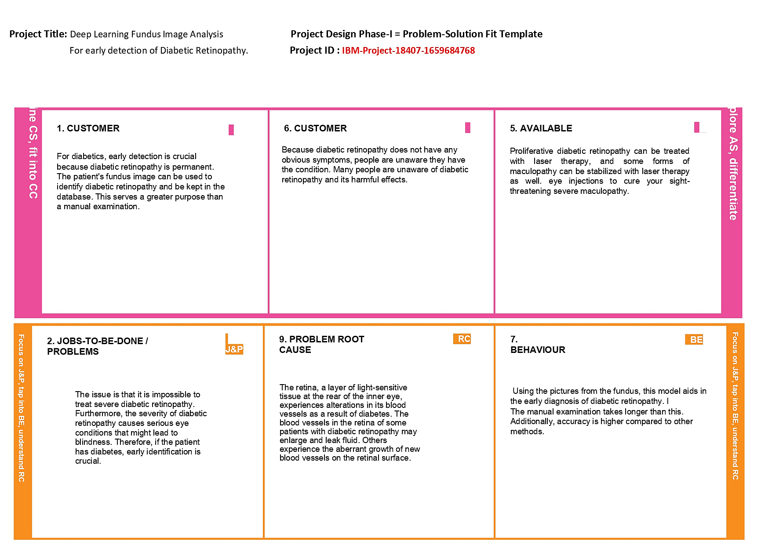

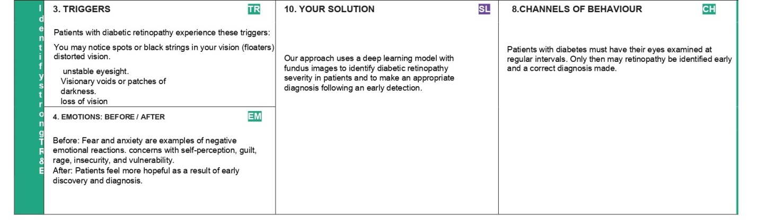

**4.REQUIREMENT ANALYSIS:-**

# FunctionalRequirements:

Followingarethefunctional requirementsoftheproposedsolution.

|  |  |  |
| --- | --- | --- |
| **FR No.** | **FunctionalRequirement(Epic)** | **SubRequirement(Story/Sub-Task)** |
| FR-1 | UserRegistration | Using a phone number to registersigningupwithGmail |
| FR-2 | UserConfirmation | Reassurance via OTP mailconfirmation |
| FR-3 | Describe whattheproductdoes | Before you notice any changes in your vision, our projectcanidentifyearlyretinalchanges. |
| FR-4 | Focusonuserrequirements | Reduce the chance of blindness and vision loss indiabetes patientswhohave retinalcomplications. |
| FR-5 | Usuallydefinedbytheuser | Apatient'sfundusimagewasobtained. |
| FR-6 | Defineproductfeatures | A cutting-edge technique for eye screening that allowsfortheearlydetectionofdiseasesrelatedtothe eyes. |

# Non-functionalRequirements:

Followingarethe non-functionalrequirementsoftheproposed solution.

|  |  |  |
| --- | --- | --- |
| **FR No.** | **Non-FunctionalRequirement** | **Description** |
| NFR-1 | **Usability** | Confirming that a piece of software can successfullycarryoutoneormorespecific tasks. |
| NFR-2 | **Security** | Only the system administrator may grantpermission. |
| NFR-3 | **Reliability** | Eventhoughthesystem hasthe abilityto rollback  to its original state if a system update fails or thereare bugs in thecode. |
| NFR-4 | **Performance** | Theloadingofanimagejusttakestwoseconds.Themodel'sperformanceisintended  toprovidepatientswithquickresults. |
| NFR-5 | **Availability** | The gadget facilitates access, cost, and quality ofhealthcare. |
| NFR-6 | **Scalability** | Even when several users are utilising the productsimultaneously,itmustremainreliable. |

**5.PROJECT DESIGN:-**

**5.1 DATA FLOW DIAGRAM:-**

# DataFlowDiagrams:

|  |  |
| --- | --- |
|  |  |
|  |  |

The classic visual representation of how information moves through a system is a data flow diagram (DFD). The ideal amount of the systemneeds can be graphically represented by a tidy and understandable DFD. It demonstrates how information enters and exits the system, whatmodifiesthe data,and where information iskept.

* Diabeticretinopathydiseaseisfrequently detectedandexaminedusingretinalfundus Pre-processing of raw retinal fundus images isperformedusing extraction of thegreenchannel,histogramequalization,imageenhancement,andresizingtechniques.
* Oneofthemaintasksinretinalimageprocessingis thesegmentationofthe retinalvasculaturefrom images oftheeyefundus.
* Byomittingtheopticdisc(OD)regionoftheretina,thecomputer-assistedautomaticrecognitionandsegmentationofbloodvessels.
* Mathematicalbinarymorphologicaltechniquesareusedtoidentifytheretinalbloodvessels.
* The term "feature extraction from the fundus images for the diagnosis of Diabetic Retinopathy" refers to a sophisticated eye screeningtechniquethatallowsforthe earlydetection ofeye-relateddisorders.

**5.2 TECHNOLOGY ARCHITECTURE:-**

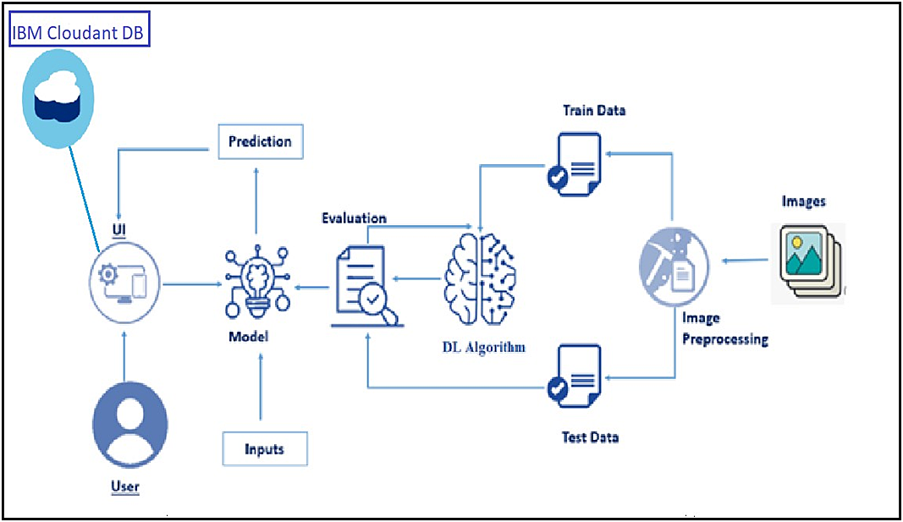

**Table-1:Components&Technologies:**

|  |  |  |  |
| --- | --- | --- | --- |
| 1. | UserInterface | WebUI | HTML,CSS,JavaScript,Python |
| 2. | Applicationlogic-1 | ImagePreprocessing | Keras,Tensorflow,Numpy |
| 3. | Applicationlogic-2 | CNNModel | Keras,Tensorflow,Numpy |
| 4. | Applicationlogic-3 | WebUIApplication | Flask |
| 5. | Database | DRImages(Jpeg,Png,Jpg,Etc.,) | UploadsFolder |
| 6. | File storage | File Storage Requirements(OnlyIfNecessary) | IBMBlockStorage,GoogleDrive |
| 7. | ExternalApi | Keras | ImageProcessingAPI |
| 8. | Deep LearningModel | InceptionV3Architecture | Pre-Trained Convolution NeuralNetworkModel |
| 9. | Infrastructure(Server) | ApplicationDeploymenton Webserver | Flask-APythonWSGIHTTPServer. |

**Table-2:Applicationcharacteristics:**

|  |  |  |  |
| --- | --- | --- | --- |
| **S.No** | **Characteristics** | **Description** | **Technology** |
| 1. | Open-SourceFrameworks | Flask | FlaskFrameworks |
| 2. | SecurityImplementations | CSRFProtection,SecureFlagForCookies | Flask-WTF, Session CookieSecure |
| 3. | ScalableArchitecture | Micro-Services | Micro Web Application FrameworkByFlask |

# 5.3 USER STORIES:-

|  |  |  |  |  |  |  |
| --- | --- | --- | --- | --- | --- | --- |
| **UserType** | **FunctionalRequirement (Epic)** | **User StoryNumber** | **UserStory/Task** | **Acceptancecriteria** | **Priority** | **Release** |
| Patient(Webuser) | Registration | USN-1 | I can register as a user on the websitewitheitheranemailaddressoraphone  numberandpassword. | Icancreatemyaccount. | High | Sprint-3 |
|  | Login | USN-2 | WiththeprovidedLogincredentials,Icanaccessthewebsiteasauser. | Icanloginandaccessmyaccount. | High | Sprint-3 |
|  | Uploadimage | USN-3 | Icanpostmydataasauserin formatslikepdfanddoc. | Icanuploadmy data. | Medium | Sprint-3 |
| Administration (Webdeveloper) | AdminLogin | USN-4 | Icanlog intothewebsite astheadmin and analyze the userinformation. | I can log in andanalyzetheuserdata. | High | Sprint-3 |
|  | Datacollection | USN-5 | IcangatherthedatasetfortheDRfromthesourceas anadmin. | Icancollectthedataset. | Low | Sprint-1 |
|  | Createmodel | USN-6 | Icanbuildthemodelandtrain itusing  thedatasetasanadministratortomakepredictions. | Icancreateandtrainthemodel. | High | Sprint-1 |
|  | Test themodel | USN-7 | Icanevaluatethemodel'spredictiveabilitiesasanadmin. | Icantestthemodel. | High | Sprint-2 |
| Patient(Webuser) | Diagnosis | USN-8 | Icanaccesstheapplication'sdiagnosisresultsasa userandcontinuewith  treatments.. | He/shecangettheresultsand continue thetreatment. | High | Sprint-2 |

**6.PROJECT PLANNING AND SCHEDULING:-**

**6.1 SPRINT PLANNING AND ESTIMATION:-**

|  |  |  |  |  |  |  |
| --- | --- | --- | --- | --- | --- | --- |
| **Sprint** | **FunctionalRequirement(Epic)** | **UserStoryNumber** | **UserStory/Task** | **StoryPoints** | **Priority** | **TeamMembers** |
| Sprint-1 | Registration | USN-1 | Asauser,Icanregisterfortheapplicationby entering my email or phone numberand password,and confirmingmy  password. | 10 | High | Vidhya V |
| Sprint-1 | Dashboard | USN-2 | Asauser,IwillRedirecttothedashboardafter registration which shows theimportanceofDR. | 10 | Medium | Vidhya V& Akila A |
| Sprint-2 | Login | USN-3 | Asauser,Icanlogintotheapplication byenteringLogin credentials. | 5 | High | Indhumathi R |
| Sprint-2 | UploadImages | USN-4 | As a user, I should be able to upload the imageofeyeRetina. | 10 | High | Sowmiya S |

|  |  |  |  |  |  |  |
| --- | --- | --- | --- | --- | --- | --- |
| Sprint-2 | Dashboard | USN-5 | Asauser,basedonmyrequirementIcannavigatethrough thedashboard. | 5 | Medium | Vidhya V |
| Sprint-3 | Trainthemodel | Task1 | Asadeveloper,thedatasetwillbeuploadedandtrainedbydevelopedalgorithm. | 20 | High | Vidhya V& Akila A |
| Sprint-4 | Testing&Evaluation | Task2 | As a developer, we tested the trained modelusing the provided dataset andmodel will beevaluatedfor accurateresults. | 10 | High | Indhumathi R |
| Sprint-4 | Displaypredictedresult | USN-6 | Asauser,Icanviewthepredictedresultinthedashboard. | 10 | High | Sowmiya S |

|  |  |  |  |  |  |  |
| --- | --- | --- | --- | --- | --- | --- |
| **Sprint** | **Totalstorypoint** | **Duration** | **SprintStartDate** | **SprintEnd Date(Planned)** | **Story Points**  **Completed (as**  **on PlannedEndDate)** | **Sprint ReleaseDate(Actual)** |
| Sprint-1 | 20 | 6 Days | 24Oct 2022 | 29Oct 2022 | 20 | 29Oct 2022 |
| Sprint-2 | 20 | 6 Days | 31Oct 2022 | 05Nov2022 | 20 | 05Nov2022 |
| Sprint-3 | 20 | 6 Days | 07Nov2022 | 12Nov2022 | 20 | 12Nov2022 |
| Sprint-4 | 20 | 6 Days | 14Nov2022 | 19Nov2022 | 20 | 19Nov2022 |

**Velocity:**

Imaginewehavea 10-daysprintduration,andthevelocityoftheteamis20(pointspersprint).Let’s calculatetheteam’saveragevelocity(AV)periterationunit(storypointsperday).

|  |  |
| --- | --- |
|  |  |
|  |  |

AV=20/6=3.33pointsperday.

# 6.2 BurnDownChart &JIRA:

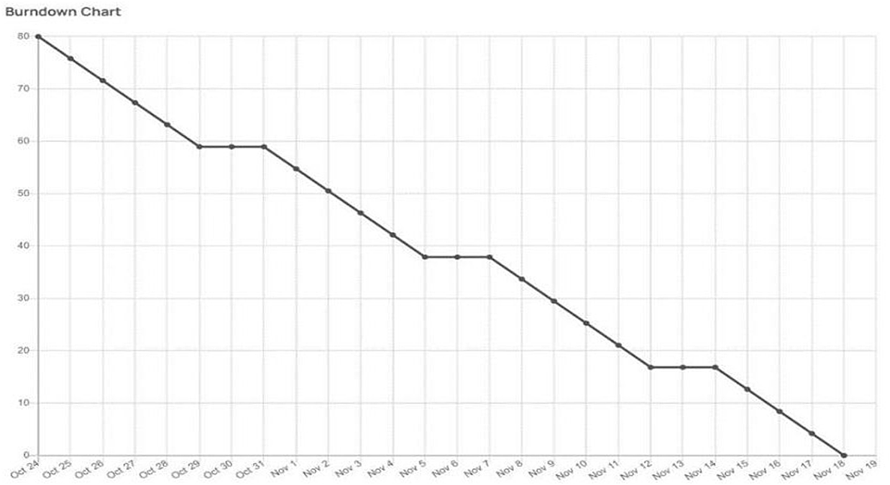

A burn down chart plots the amount of work remaining to perform against the amount of time. In agilesoftwaredevelopmentapproacheslikeScrum,itisfrequentlyemployed.Burndowncharts,however,canbeused forany projectthatmakesobservableprogressovertime.

|  |  |  |  |  |  |  |  |  |  |  |  |  |  |  |  |  |  |  |  |  |  |  |  |  |  |  |  |  |  |  |  |  |  |  |  |  |  |  |  |  |  |  |  |  |  |  |  |  |  |  |  |  |  |  |  |  |  |  |  |  |  |  |  |  |  |  |  |  |  |  |  |  |  |  |  |  |  |  |  |  |  |  |  |  |  |  |  |  |  |  |  |  |  |  |  |  |  |  |  |  |  |  |  |  |  |  |  |  |  |  |  |  |  |
| --- | --- | --- | --- | --- | --- | --- | --- | --- | --- | --- | --- | --- | --- | --- | --- | --- | --- | --- | --- | --- | --- | --- | --- | --- | --- | --- | --- | --- | --- | --- | --- | --- | --- | --- | --- | --- | --- | --- | --- | --- | --- | --- | --- | --- | --- | --- | --- | --- | --- | --- | --- | --- | --- | --- | --- | --- | --- | --- | --- | --- | --- | --- | --- | --- | --- | --- | --- | --- | --- | --- | --- | --- | --- | --- | --- | --- | --- | --- | --- | --- | --- | --- | --- | --- | --- | --- | --- | --- | --- | --- | --- | --- | --- | --- | --- | --- | --- | --- | --- | --- | --- | --- | --- | --- | --- | --- | --- | --- | --- | --- | --- | --- | --- |
|  | **7.CODING AND SOLUTIONING:-**  **Feature 1:-**  We have devloped a website which authenticates users and help them upload  and check the seriousness of the diabetics.  **Feature 2:-**  We have devloped a multilayer deep convolutional nueral network that classifies  the user image of a eye to which extense has the disease diabetics has been  affected.The model will classify the images into 5 categories of diabetics and  report them on asking for prediction. We have also devloped a messaging service  for recieiving message for the type of diabetics.  **8.TESTING:-**  **8.1 TEST CASES:-**  **8.2 USER ACCEPTANCE TESTING:-**  **1.Purpose of Document:-**  This document serves as a quick reference for the Deep Learning Fundus Image Analysis  for Early Detection of Diabetic Retinopathy project's test coverage and open issues as  of the project's release for user acceptance testing. 2. Defect Analysis:- This shows how many bugs were fixed or closed at each severity level and how they were fixed.   |  |  |  |  |  |  | | --- | --- | --- | --- | --- | --- | | **Resolution** | **Severity 1** | **Severity 2** | **Severity 3** | **Severity4** | **Subtotal** | | By Design | 5 | 4 | 2 | 3 | 14 | | Duplicate | 1 | 0 | 3 | 0 | 4 | | External | 2 | 3 | 0 | 1 | 6 | | Fixed | 9 | 2 | 4 | 15 | 30 | | Not Reproduced | 0 | 0 | 1 | 0 | 1 | | Skipped | 0 | 0 | 1 | 1 | 2 | | Won'tFix | 0 | 5 | 2 | 1 | 8 | | Totals | 17 | 14 | 13 | 21 | 65 |  3.Test-CaseAnalysis This report shows the number of test cases that have passed, failed,and untested.   |  |  |  |  |  | | --- | --- | --- | --- | --- | | **Section** | **TotalCases** | **Not Tested** | **Fail** | **Pass** | | PrintEngine | 9 | 0 | 0 | 9 | | ClientApplication | 45 | 0 | 0 | 45 | | Security | 2 | 0 | 0 | 2 | | Out-sourceShipping | 3 | 0 | 0 | 3 | | ExceptionReporting | 9 | 0 | 0 | 9 | | FinalReportOutput | 4 | 0 | 0 | 4 | | VersionControl | 2 | 0 | 0 | 2 |     **9.RESULTS:-**  **9.1 PerformanceMetrics:-**  **ModelPerformanceTesting:**   |  |  |  |  |  |  |  |  |  |  |  |  |  |  |  |  |  |  | | --- | --- | --- | --- | --- | --- | --- | --- | --- | --- | --- | --- | --- | --- | --- | --- | --- | --- | | |  |  |  |  |  |  |  |  |  |  |  |  |  |  |  |  |  | | --- | --- | --- | --- | --- | --- | --- | --- | --- | --- | --- | --- | --- | --- | --- | --- | --- | | |  |  |  |  | | --- | --- | --- | --- | | **S.No:**SS**PerforS.NO** | **ParameterPe Parameter** | **Values** | **Screenshot** | | 1. | ModelSummary | **Totalparams:21,885,485**  **Trainableparams:1,024,005**  **Non-trainableparams:20,861,480** |  | | 2. | Accuracy | TrainingAccuracy–**0.7917**  ValidationAccuracy– **loss3.2610** |  | | 3. | Confidence Score(Only YoloProjects) | ClassDetected-ConfidenceScore - | -------- | | |   Projectteamshallfillthefollowinginformationinmodelperformancetestingtemplate.  **10.ADVANTAGES AND DISADVANTAGES:-**  **10.1 ADVANTAGES:-**  There are several advantages of using deep learning for fundus image analysis for early detection of diabetic retinopathy.  First, deep learning is well-suited for image analysis tasks. This is because deep learning algorithms can automatically learn features from images, which is essential for accurate image analysis.  Second, deep learning is efficient at handling large amounts of data. This is important for medical image analysis, as medical images are often very large.  Third, deep learning is scalable. This means that it can be used to train models on very large datasets, which is important for medical image analysis tasks where data is often limited.  Fourth, deep learning is able to learn from data with little supervision. This is important for medical image analysis, as often there is limited labeled data available.  Finally, deep learning is robust. This means that it is less likely to overfit to the data, which is important for medical image analysis where data is often limited.  **10.2 DISADVANTAGES:-**  There are several disadvantages of deep learning for early detection of diabetic retinopathy. One disadvantage is that deep learning requires a large amount of data to train the models. This can be a challenge for researchers who do not have access to a large dataset. Another challenge is that deep learning models can be very complex, which can make them difficult to interpret. Finally, deep learning models can be computationally intensive, which can make them difficult to deploy in resource-limited settings.  **11.CONCLUSION:-**  Diabetic retinopathy (DR) is a leading cause of blindness in the United States. Early detection and treatment of DR is critical to preventing vision loss. However, DR is often asymptomatic in its early stages, making it difficult to detect.  Deep learning (DL) is a type of artificial intelligence that can be used to automatically detect patterns in data. DL has been shown to be effective for detecting DR in images of the retina.  In this study, a DL algorithm was used to automatically detect DR in fundus images. The algorithm was able to accurately detect DR in early stages, before it is symptomatic. This could potentially lead to earlier diagnosis and treatment of DR, which could help to prevent vision loss.  **12.FUTURE SCOPE:-**  There is a great potential for deep learning in fundus image analysis for early detection of diabetic retinopathy. However, there are a few challenges that need to be addressed. First, the current data sets are small and lack diversity. Second, the images are often low quality and need to be pre-processed before they can be used for deep learning. Third, the ground truth labels for the images are often not available. Finally, the current deep learning models are not able to generalize well to real-world data.  **13.APPENDIX:-**  **app.py:-**  import numpy as np  import os  from tensorflow.keras.models import load_model  from tensorflow.keras.preprocessing import image  from tensorflow.keras.applications.inception_v3 import preprocess_input  from flask import Flask, request,flash, render_template, redirect,url_for  from cloudant.client import Cloudant  from twilio.rest import Client  model = load_model(r"Updated-xception-diabetic-retinopathy.h5")  app = Flask(__name__)  app.secret_key="abc"  app.config['UPLOAD_FOLDER'] = "User_Images"  # Authenticate using an IAM API key  client = Cloudant.iam('08bcbaf0-260b-48e0-abdb-08db348afcf2-bluemix',  'yhZfUubpS3vS1vEKZSS37teD6IAUi8oLynOCQLIwnQsa', connect=True)  # Create a database using an initialized client  my_database = client.create_database('my_database')  if my_database.exists():  print("Database '{0}' successfully created.".format('my_db'))  # default home page or route  user = ""  @app.route('/')  def index():  return render_template('index.html', pred="Login", vis ="visible")  @ app.route('/index')  def home():  return render_template("index.html", pred="Login", vis ="visible")    # registration page  @ app.route('/register',methods=["GET","POST"])  def register():  if request.method == "POST":  name = request.form.get("name")  mail = request.form.get("emailid")  mobile = request.form.get("num")  pswd = request.form.get("pass")  data = {  'name': name,  'mail': mail,  'mobile': mobile,  'psw': pswd  }  print(data)  query = {'mail': {'$eq': data['mail']}}  docs = my_database.get_query_result(query)  print(docs)  print(len(docs.all()))  if (len(docs.all()) == 0):  url = my_database.create_document(data)  return render_template("register.html", pred=" Registration Successful , please login using your details ")  else:  return render_template('register.html', pred=" You are already a member , please login using your details ")  else:  return render_template('register.html')    @ app.route('/login', methods=['GET','POST'])  def login():  if request.method == "GET":  user = request.args.get('mail')  passw = request.args.get('pass')  print(user, passw)  query = {'mail': {'$eq': user}}  docs = my_database.get_query_result(query)  print(docs)  print(len(docs.all()))  if (len(docs.all()) == 0):  return render_template('login.html', pred="")  else:  if ((user == docs[0][0]['mail'] and passw == docs[0][0]['psw'])):  flash("Logged in as " + str(user))  return render_template('index.html', pred="Logged in as "+str(user), vis ="hidden", vis2="visible")  else:  return render_template('login.html', pred="The password is wrong.")  else:  return render_template('login.html')    @ app.route('/logout')  def logout():  return render_template('logout.html')  @app.route("/predict",methods=["GET", "POST"])  def predict():  if request.method == "POST":  f = request.files['file']  # getting the current path 1.e where app.py is present  basepath = os.path.dirname(__file__)  #print ( " current path " , basepath )  # from anywhere in the system we can give image but we want that  filepath = os.path.join(str(basepath), 'User_Images', str(f.filename))  #print ( " upload folder is " , filepath )  f.save(filepath)  img = image.load_img(filepath, target_size=(299, 299))  x = image.img_to_array(img) #ing to array  x = np.expand_dims(x, axis=0) # used for adding one more dimension  #print ( x )  img_data = preprocess_input(x)  prediction = np.argmax(model.predict(img_data), axis=1)  index = [' No Diabetic Retinopathy ', ' Mild NPDR ',  ' Moderate NPDR ', ' Severe NPDR ', ' Proliferative DR ']  result = str(index[prediction[0]])  print(result)  account_sid = 'AC8e0f2f5263d71c8f630a6486779cf08b'  auth_token = '30b489873afb3c47340070eabd6bfb15'  client = Client(account_sid, auth_token)  ''' Change the value of 'from' with the number  received from Twilio and the value of 'to'  with the number in which you want to send message.'''  message = client.messages.create(  from_='+16075363206',  body ='Results: '+ result,  to ='+919445979800'  )  return render_template('prediction.html', prediction=result, fname = filepath)  else:  return render_template("prediction.html")  if __name__ == "__main__":  app.debug = True  app.run()  **cloud.ipynb:-**  from cloudant.client import Cloudant  client=Cloudant.iam('655489f8-18d0-4a44-a701-5de60570a973-bluemix','Jc4eF6CXk72w0wGCsM_KUuXKVjsCcT4a54UKBXckK5Bv',connect=True)  my_database=client.create_database('my-database')  **index.html:-**  <!DOCTYPE html>  <html lang="en">  <head>  <meta charset="UTF-8" />  <meta http-equiv="X-UA-Compatible" content="IE=edge" />  <meta name="viewport" content="width=device-width, initial-scale=1.0" />  <!-- CSS only -->  <link  href="https://cdn.jsdelivr.net/npm/bootstrap@5.2.1/dist/css/bootstrap.min.css"  rel="stylesheet"  integrity="sha384-iYQeCzEYFbKjA/T2uDLTpkwGzCiq6soy8tYaI1GyVh/UjpbCx/TYkiZhlZB6+fzT"  crossorigin="anonymous"  />  <!-- JavaScript Bundle with Popper -->  <script  src="https://cdn.jsdelivr.net/npm/bootstrap@5.2.1/dist/js/bootstrap.bundle.min.js"  integrity="sha384-u1OknCvxWvY5kfmNBILK2hRnQC3Pr17a+RTT6rIHI7NnikvbZlHgTPOOmMi466C8"  crossorigin="anonymous"  ></script>  <style>  #navbarRight {  margin-left: auto;  padding-right:10px;  }  .navbar-brand{  padding-left:15px;  }  </style>  <title>DR Predcition</title>  </head>  <body>  <nav class="navbar navbar-expand-lg navbar-light bg-dark">  <div>  <a class="navbar-brand" href="#" style="color:aliceblue">Diabetic Retinopathy Classification</a>  </div>  {{msg}}  <div class="navbar-collapse collapse w-100 order-3 dual-collapse2" id="navbarNav">  <ul class="navbar-nav mr-auto text-center" id="navbarRight">  <li class="nav-item active">  <a class="nav-link" href="index" style="color: aliceblue;">Home </a>  </li>  <li class="nav-item" style="visibility:{{ vis2 }}">  <a class="nav-link" href="predict" style="color: aliceblue;">Prediction</a>  </li>  <li class="nav-item">  <a class="nav-link" href="login" style="color: aliceblue;">{{pred}}</a>  </li>  <li class="nav-item" style="visibility:{{ vis }}">  <a class="nav-link" href="register" style="color: aliceblue;">Register</a>  </li>  </ul>  </div>  </nav>  <br><br>  <div class="jumbotron container">  <h1 class="display-4">Diabetic Retinopathy</h1>  <p class="lead">Diabetic retinopathy is a diabetes complication that affects eyes. It's caused by damage to the blood vessels of the light-sensitive tissue at the back of the eye (retina).  At first, diabetic retinopathy might cause no symptoms or only mild vision problems. But it can lead to blindness.  The condition can develop in anyone who has type 1 or type 2 diabetes. The longer you have diabetes and the less controlled your blood sugar is, the more likely you are to develop this eye complication.</p>  <hr class="my-4">  <div class="d-flex justify-content-center">  <img style="width:70vw;" src="static/diabetic-retinopathy-home.jpg">  </div>  </div>  </body>  </html>  **login.html:-**  <!DOCTYPE html>  <html lang="en">  <head>  <meta charset="UTF-8" />  <meta http-equiv="X-UA-Compatible" content="IE=edge" />  <meta name="viewport" content="width=device-width, initial-scale=1.0" />  <!-- CSS only -->  <link  href="https://cdn.jsdelivr.net/npm/bootstrap@5.2.1/dist/css/bootstrap.min.css"  rel="stylesheet"  integrity="sha384-iYQeCzEYFbKjA/T2uDLTpkwGzCiq6soy8tYaI1GyVh/UjpbCx/TYkiZhlZB6+fzT"  crossorigin="anonymous"  />  <!-- JavaScript Bundle with Popper -->  <script  src="https://cdn.jsdelivr.net/npm/bootstrap@5.2.1/dist/js/bootstrap.bundle.min.js"  integrity="sha384-u1OknCvxWvY5kfmNBILK2hRnQC3Pr17a+RTT6rIHI7NnikvbZlHgTPOOmMi466C8"  crossorigin="anonymous"  ></script>  <style>  #navbarRight {  margin-left: auto;  padding-right:10px;  }  .navbar-brand{  padding-left:15px;  }  </style>  <title>DR Predcition</title>  </head>  <form action="",method='POST'>  <nav class="navbar navbar-expand-lg navbar-light bg-dark">  <div>  <a class="navbar-brand" href="#" style="color:aliceblue">User Login</a>  </div>  <div class="navbar-collapse collapse w-100 order-3 dual-collapse2" id="navbarNav">  <ul class="navbar-nav mr-auto text-center" id="navbarRight">  <li class="nav-item active">  <a class="nav-link" href="index" style="color: aliceblue;">Home </a>  </li>  <li class="nav-item">  <a class="nav-link" href="login" style="color: aliceblue;">Login</a>  </li>  <li class="nav-item">  <a class="nav-link" href="register"style="color: aliceblue;">Register</a>  </li>  </ul>  </div>  </nav>  <br><br>  <form class="form-inline" action="/login" method="GET">  <div class="container" style="width: 600px; height: 600px;">  <div class="mb-3 d-flex justify-content-center"><script src="https://cdn.lordicon.com/xdjxvujz.js"></script>  <lord-icon  src="https://cdn.lordicon.com/elkhjhci.json"  trigger="hover"  style="width:200px;height:200px">  </lord-icon></div>  <div class="mb-3">  <input type="email" class="form-control" id="exampleInputEmail1" name="mail" aria-describedby="emailHelp" placeholder="Enter Registered Mail ID">  </div>  <div class="mb-3">  <input type="password" class="form-control" id="exampleInputPassword1" name="pass" placeholder="Enter Password">  </div>  <div class="mb-3">  <button type="submit form-control" class="btnbtn-dark btn-primary" style="width:100%;" type="submit">Login</button>  </div>  {{pred}}  </div>  </form>  </body>  </html>  **logout.html**  <!DOCTYPE html>  <html lang="en">  <head>  <meta charset="UTF-8" />  <meta http-equiv="X-UA-Compatible" content="IE=edge" />  <meta name="viewport" content="width=device-width, initial-scale=1.0" />  <!-- CSS only -->  <link  href="https://cdn.jsdelivr.net/npm/bootstrap@5.2.1/dist/css/bootstrap.min.css"  rel="stylesheet"  integrity="sha384-iYQeCzEYFbKjA/T2uDLTpkwGzCiq6soy8tYaI1GyVh/UjpbCx/TYkiZhlZB6+fzT"  crossorigin="anonymous"  />  <!-- JavaScript Bundle with Popper -->  <script  src="https://cdn.jsdelivr.net/npm/bootstrap@5.2.1/dist/js/bootstrap.bundle.min.js"  integrity="sha384-u1OknCvxWvY5kfmNBILK2hRnQC3Pr17a+RTT6rIHI7NnikvbZlHgTPOOmMi466C8"  crossorigin="anonymous"  ></script>  <style>  #navbarRight {  margin-left: auto;  padding-right:10px;  }  .navbar-brand{  padding-left:15px;  }  </style>  <title>DR Predcition</title>  </head>  <body>  <nav class="navbar navbar-expand-lg navbar-light bg-dark">  <div>  <a class="navbar-brand" href="#" style="color:aliceblue">Diabetic Retinopathy</a>  </div>  <div class="navbar-collapse collapse w-100 order-3 dual-collapse2" id="navbarNav">  <ul class="navbar-nav mr-auto text-center" id="navbarRight">  <li class="nav-item active">  <a class="nav-link" href="index" style="color: aliceblue;">Home </a>  </li>  <li class="nav-item">  <a class="nav-link" href="login" style="color: aliceblue;">Login</a>  </li>  <li class="nav-item">  <a class="nav-link" href="register"style="color: aliceblue;">Register</a>  </li>  </ul>  </div>  </nav>  <br><br>  <div class="d-flex justify-content-center">  <div class="row d-flex display-3 justify-content-center">  Successfully Logged Out!  <br><br>  <a href="login" class="btnbtn-lgbtn-dark">Login for more Information</a>  </div>  </div>  </body>  </html>  **prediction.html:-**  <!DOCTYPE html>  <html lang="en">  <head>  <meta charset="UTF-8" />  <meta http-equiv="X-UA-Compatible" content="IE=edge" />  <meta name="viewport" content="width=device-width, initial-scale=1.0" />  <!-- CSS only -->  <link href="https://cdn.jsdelivr.net/npm/bootstrap@5.2.1/dist/css/bootstrap.min.css" rel="stylesheet"  integrity="sha384-iYQeCzEYFbKjA/T2uDLTpkwGzCiq6soy8tYaI1GyVh/UjpbCx/TYkiZhlZB6+fzT" crossorigin="anonymous" />  <!-- JavaScript Bundle with Popper -->  <script src="https://cdn.jsdelivr.net/npm/bootstrap@5.2.1/dist/js/bootstrap.bundle.min.js"  integrity="sha384-u1OknCvxWvY5kfmNBILK2hRnQC3Pr17a+RTT6rIHI7NnikvbZlHgTPOOmMi466C8"  crossorigin="anonymous"></script>  <style>  #navbarRight {  margin-left: auto;  padding-right: 10px;  }  .navbar-brand {  padding-left: 15px;  }  .row {  width: 90%;  }  </style>  <title>DR Predcition</title>  </head>  <body>  <nav class="navbar navbar-expand-lg navbar-light bg-dark">  <div>  <a class="navbar-brand" href="#" style="color:aliceblue">Diabetic Retinopathy Classification</a>  </div>  <div class="navbar-collapse collapse w-100 order-3 dual-collapse2" id="navbarNav">  <ul class="navbar-nav mr-auto text-center" id="navbarRight">  <li class="nav-item active">  <a class="nav-link" href="index" style="color: aliceblue;">Home </a>  </li>  <li class="nav-item">  <a class="nav-link" href="logout" style="color: aliceblue;">Logout</a>  </li>  </ul>  </div>  </nav>  <br><br>  <div class="container justify-content-center" style="width:700px">  <form action = "/predict" method = "POST" enctype="multipart/form-data">  <label for="formFileLg" class="form-label">Upload Image</label>  <input class="form-control form-control-lg" name ="file" type="file" />  <br>  <button class="btnbtn-lgbtn-dark" type = "submit">Predict</button>  </form>  <br>  <h1>{{prediction}}</h1>  </div>  <br><br><br>  <div class="d-flex justify-content-center" >  <imgsrc="static/level.png" style="width: 90%">  </div>  </body>  </html>  **register.html:-**  <!--<!DOCTYPE html>  <html lang="en">  <head>  <meta charset="UTF-8" />  <meta http-equiv="X-UA-Compatible" content="IE=edge" />  <meta name="viewport" content="width=device-width, initial-scale=1.0" />  <!-- CSS only -->  <link  href="https://cdn.jsdelivr.net/npm/bootstrap@5.2.1/dist/css/bootstrap.min.css"  rel="stylesheet"  integrity="sha384-iYQeCzEYFbKjA/T2uDLTpkwGzCiq6soy8tYaI1GyVh/UjpbCx/TYkiZhlZB6+fzT"  crossorigin="anonymous"  />  <!-- JavaScript Bundle with Popper -->  <script  src="https://cdn.jsdelivr.net/npm/bootstrap@5.2.1/dist/js/bootstrap.bundle.min.js"  integrity="sha384-u1OknCvxWvY5kfmNBILK2hRnQC3Pr17a+RTT6rIHI7NnikvbZlHgTPOOmMi466C8"  crossorigin="anonymous"  ></script>  <style>  #navbarRight {  margin-left: auto;  padding-right:10px;  }  .navbar-brand{  padding-left:15px;  }  </style>  <title>DR Predcition</title>  </head>  <form action="{{url_for('register')}}" method="post" >  <nav class="navbar navbar-expand-lg navbar-light bg-dark">  <div>  <a class="navbar-brand" href="#" style="color:aliceblue">Registration</a>  </div>  <div class="navbar-collapse collapse w-100 order-3 dual-collapse2" id="navbarNav">  <ul class="navbar-nav mr-auto text-center" id="navbarRight">  <li class="nav-item active">  <a class="nav-link" href="index" style="color: aliceblue;">Home </a>  </li>  <li class="nav-item">  <a class="nav-link" href="login" style="color: aliceblue;">Login</a>  </li>  <li class="nav-item">  <a class="nav-link" href="register"style="color: aliceblue;">Register</a>  </li>  </ul>  </div>  </nav>  <br><br>  <form class="form-inline" method ="POST">  <div class="container" style="width: 600px; height: 600px;">  <div class="mb-3 d-flex justify-content-center"><script src="https://cdn.lordicon.com/xdjxvujz.js"></script>  <lord-icon  src="https://cdn.lordicon.com/elkhjhci.json"  trigger="hover"  style="width:200px;height:200px">  </lord-icon></div>  <div class="mb-3">  <input type="text" class="form-control" id="exampleInputName" name = "name" aria-describedby="nameHelp" placeholder="Enter Name">  </div>  <div class="mb-3">  <input type="email" class="form-control" id="exampleInputEmail1" name="emailid" aria-describedby="emailHelp" placeholder="Enter Mail ID">  </div>  <div class="mb-3">  <input type="number" class="form-control" id="exampleInputNumber1" name="num" aria-describedby="numberHelp" placeholder="Enter Mobile number">  </div>  <div class="mb-3">  <input type="password" class="form-control" id="exampleInputPassword1" name="pass" placeholder="Enter Password">  </div>  <div class="mb-3">  <button type="submit form-control" class="btnbtn-dark btn-primary" style="width:100%;">Register</button>  </div>  <div class="mb-3 d-flex justify-content-center">  <a href="login" class="nav-link"> Already Registered: Login Here</a>  </div>  {{pred}}  </div>  </form>  </body>  </html> -->  **Python Notebook screenshots:-**              **GITHUB LINK:- https://github.com/IBM-EPBL/IBM-Project-47267-1660797900**  **DEMO LINK:-** |
|  |  |
|  |  |
|  |  |
|  |  |